RON AMOS HONORED WITH IPPS EASTERN REGION AWARD OF MERIT

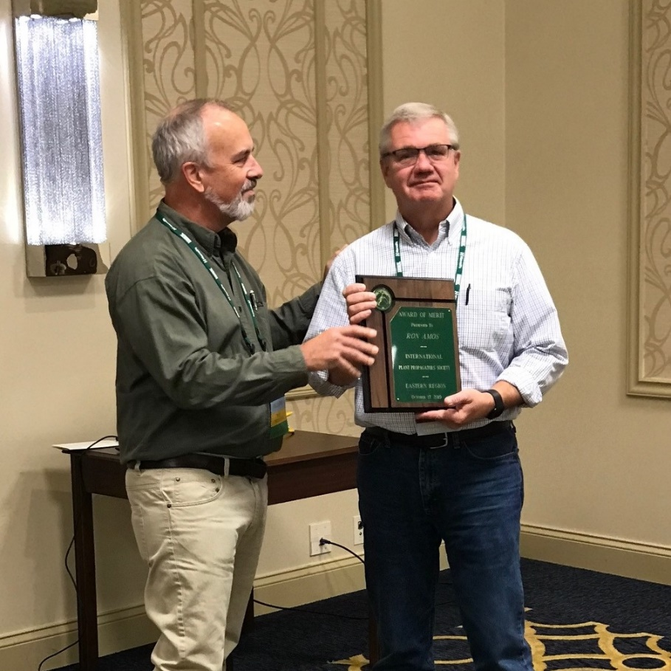
The 2019 Award of Merit was presented to Ron Amos, President of Evergreen Nursery in Sturgeon Bay, Wisconsin on October 17, 2019. The Award of Merit of the IPPS - Eastern Region is the highest honor that the Region can award to its members for outstanding contributions to the Region and to plant
propagation and production. The Award of Merit recipient is recognized for significant contributions to plant propagation or production in one or more of the following areas:

1) scientific discovery or application of facts to the propagation or production of plants;
2) development of new plant propagation or production practices or techniques;
3) services rendered to the science & practice of plant propagation or production;
Recognition Committee Chair Brian Maynard, left, presents the award plaque to Ron Amos.
4) extraordinary service to the Society.

Ron joined IPPS in 1984 and received the Fellow Award in 2006. He was President of the Eastern Region in 2014 and has served on no less than 10 different Eastern Region committees. He currently is serving on the IPPS Eastern Region Foundation Board and is on the Local Site Committee for the Madison conference.

Ron developed his interest in plants at a young age. A native of Madison, Wisconsin, he worked for Olds Garden Centers (now Jung Garden Centers) during high school and college. He went on to receive his Bachelor and Master of Science degrees from the University of Wisconsin in Madison. His Master’s research, on the tissue culture of birches, was conducted under the direction of Professor Brent McCown.

After receiving his graduate degree in 1982 our honoree joined the staff of Evergreen Nursery Company in Sturgeon Bay, Wisconsin, as a plant propagator, rising to Vice President in 1995, and eventually taking the reins as President in 2001 when 4th generation owner, Tom Pinney, Jr. retired. Evergreen Nursery Company is now over 150 years old and specializes in evergreens, shrubs, birch, and fruit liners, producing over three million liners a year on 446 acres – making it the largest wholesale nursery in the state of Wisconsin. Recently Evergreen has started propagating cranberries, and in 2014 produced over 2 million cranberry liners.

Tom Pinney complimented our honoree in Nursery Management magazine by saying “(He) is such a good grower and propagator that it really doesn’t matter whether he is growing birch, evergreens, or cranberries.” Our honoree is also an expert in overwintering liners in Wisconsin’s harsh climate and managing mycorrhiza in his nursery’s soils. And when he’s not busy running Wisconsin's largest wholesale nursery, he enjoys juggling (watch out when he's practicing with the hammers), photography and bicycling. By his own admission, he also relishes being “one of the old-timers that we used to make fun of.”

Our Award of Merit awardee was our clear choice this year. One nominator wrote “He has successfully carried on a century old nursery in Wisconsin and has helped introduce … new cultivars of bronze borer resistant paper birch - “Renaissance Oasis” specifically - into the trade after decades of testing and study. He lives and breathes propagation and is a hell of a nice guy too.”

