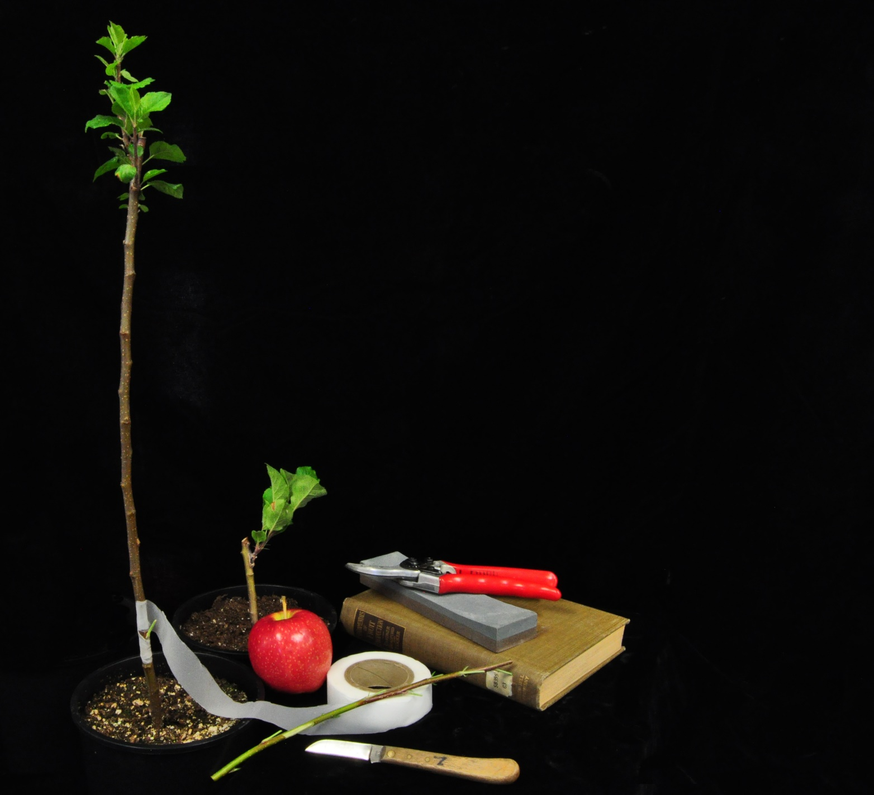
International Plant Propagator’s Society
2016 Annual Western Region Meeting
Call for Posters

IPPS Western Region

2016 POSTER INFORMATION

Submissions due September 26, 2016

The Western Region of the International Plant Propagators' Society is soliciting posters for the 2016 Annual Meeting in Tempe, Arizona on October 19-22. This event brings together educators, researchers, professionals and students in the field of plant propagation and related disciplines. Any research, development, or horticultural practice about plant propagation or plant production is appropriate as long as it is non-commercial in nature. Posters do not have to be academic or scientific in nature! If you have an innovative technique or method for growing plants, feel free to share it through a poster. Membership in IPPS is not required.

Posters should be vertically formatted and be up to 35-inches wide by 47-inches tall. They will be mounted on 6’ x 4’ tack boards with push pins. General directions on how to develop a poster can be found at these websites:

http://www.ncsu.edu/project/posters/
http://dept.ca.uky.edu/PLS440/IPPS/ER-IPPSPoster.pdf

Specific requirements for posters include:
- The poster title, author, and affiliation should be on the top of the poster.
- Lettering for the title should be at least 1-inch tall, other text may be smaller, but should be legible from two feet away.
- Authors are encouraged to include a photograph in the poster to assist in identification.
- Photos, graphs and figures should predominate over text.

A one page summary of the poster's content should accompany the application. If accepted, the summary will be archived and published in the 2016 Combined Proceedings. Published articles are fully copyright protected. A digital copy of the poster can also be archived. Please include the author's name(s), affiliation, address, phone number and email address on the summary.

Accepted posters can be shipped to the address below or hand delivered to the Annual Meeting at the Tempe Mission Palms Hotel by 5:00 pm Wednesday, October 19. They will be removed Saturday, October 22, at 1:00 pm and can be picked up at that time or returned by mail toward the end of October in the same mailing tube in which they arrived. Please submit the application and summary by September 26; you will be contacted if your poster is selected for display.

Please submit application and summary to:
Larry A. Rupp
Plants, Soils, and Climate Department, Utah State University
Larry.Rupp@usu.edu

Posters may be hand carried to the meeting, or mailed directly to:
Tempe Mission Palms Hotel
IPPS Western Region Annual Meeting
60 East Fifth Street
Tempe, AZ 85281
USA

APPLICATION FORM
2016 POSTER SESSION
Western Region IPPS Annual Meeting
October 19-22, 2016
Tempe Mission Palms Hotel
60 East Fifth Street
Tempe, Arizona

See accompanying “IPPS Poster Information” sheet for details.
Please supply the following information and return this form by Sept. 26, 2016 to:

Larry A. Rupp
Plants, Soils, and Climate Department
4820 Old Main Hill
Utah State University
Logan, Utah 84322-4820 USA
Larry.Rupp@usu.edu
435-232-1158

Title of Poster ____________________________________________________

Presenter(s)/Authors(s)_______________________________________________

Company/Affiliation: _______________________________________________

Address: _________________________________________________________

_________________________________________________________________

Telephone: ____________________________ Fax: _______________________

E-mail address: ____________________________________________________

Size of Poster: ___________________Do you want it returned to you? ________

Please attach a formal, one-page summary of the poster content. Should your poster be accepted for the meeting, this summary will be published in the 2016 Combined Proceedings.

Thank you for participating in the Poster & Display Session of the 57th Annual Meeting of the Western Region of the International Plant Propagators’ Society!

